First announcement for

László Tabár’s New Breast Imaging Course in Sigtuna, Sweden
Faculty member and breast MRI expert: Mats Ingvarsson, MD.

Newly designed hands-on breast and interactive screening and diagnosis course in 2019. The course is specifically designed to teach radiologists at all levels of experience in breast imaging, MRI included.

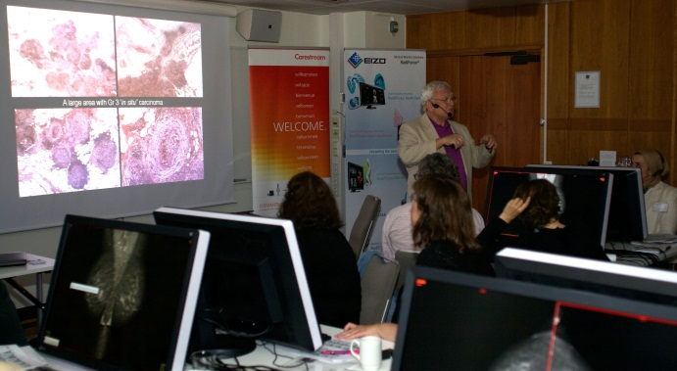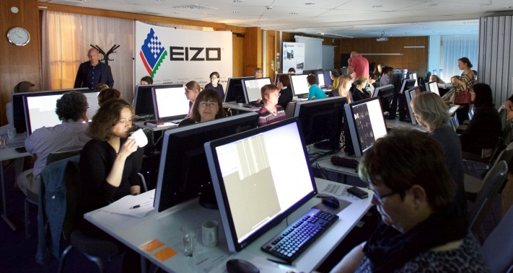
Case discussion with László Tabár Case discussion with Mats Ingvarsson

Objectives of the hands-on course:
• Learning how to minimize call-back rates without missing cancers.
• Gaining greater skill and confidence in reading large numbers of mammograms.
• Progressively improving interpretive expertise during the course.
• Learning to characterize breast lesions utilizing multimodality imaging, breast MRI included.

Date: Oct 15-18, 2019.

Course site: Hotel Kristina, Sigtuna, Sweden
http://www.hotellkristina.se

Hotel room booking: see information below
- The course will be held on Oct 15-18th, but a hotel room needs to be reserved for Aug 15th).
- HOTEL ROOM RESERVATION:
On the website below (see url) you can reserve room with breakfast. The price of a single room is 1400 SEK (VAT incl) /night, 2,000 SEK for double /twin beds including breakfast buffet. http://online.bookvisit.com/v2/Campaign/CampaignDetails?channelId=b4321edd-352a-4ac2-89bd-62d1bf4f8eb1&campaignId=33960195-3962-47e1-9547-e13b15a8ef13
Code: Mammography
- Also, you can reserve dinner for 14th, 16th, and17th Oct in advance at a cost of 250 SEK/dinner.
- The course tuition includes dinner on Oct 15th.

Course tuition: SEK 11 900.- or $ US 1,480.- See the banking information on MEI’s website (www.mammographyed.com) or on the attached Registration form. Please provide the VAT (moms) registration number of the organization (hospital, County Council, etc.) that pays the tuition.

Registration to the courses
- Online at: http://www.mammographyed.com
- Alternatively by filling in the attached Registration form and mailing it to laszlo@mammographyed.com.

Course description: The detailed schedule is attached, but it is also available on the internet: www.mammographyed.com
Oct 15-18, 2019:
https://www.dropbox.com/s/kek6m4upjllzjt8/Sigtuna%20Oct%2015-%2018%202019.pdf?dl=0
Continuing Medical Education (CME) credits:
• This course qualifies for Category I CME credits (continuing medical education) accredited by the American ACCME (Accreditation Council for Continuing Medical Education) through Mammography Education, Inc. (MEI).

Welcome to Hotel Kristina, Sigtuna to fine-tune your screening and diagnostic skills!

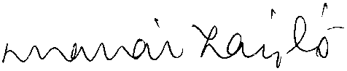
László Tabár, MD, FACR (Hon).

